CAED LAB 09

**Name: Muhammad Saad Aslam I.D: FA17-BECE-0028**

**Task 1:**

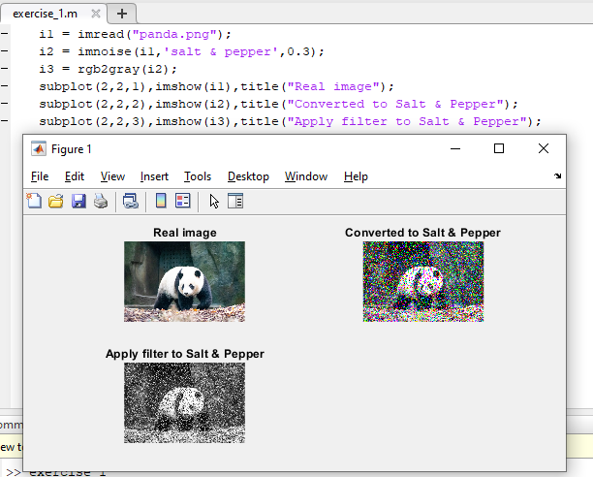

**Task 2:**

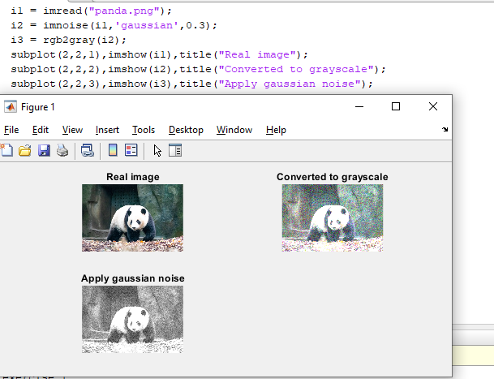

**Task 3:**

